Scope 1
- DG SET: Emissions (KgCO2e) = Fuel Consumed (L) x EF of Diesel (KgCO2e/L)
- LPG Consumption = Fuel Consumed (L) x EF of LPG (KgCO2e/L)
- Campus Owned Vehicles: Emissions(KgCO2e) = Fuel Consumed (L) x EF of fuel(KgCO2e/L)
- Fugitive Emissions: Emissions (KgCO2e) = (Fuel refilled (Kg) x GWP of refrigerant) / 1000
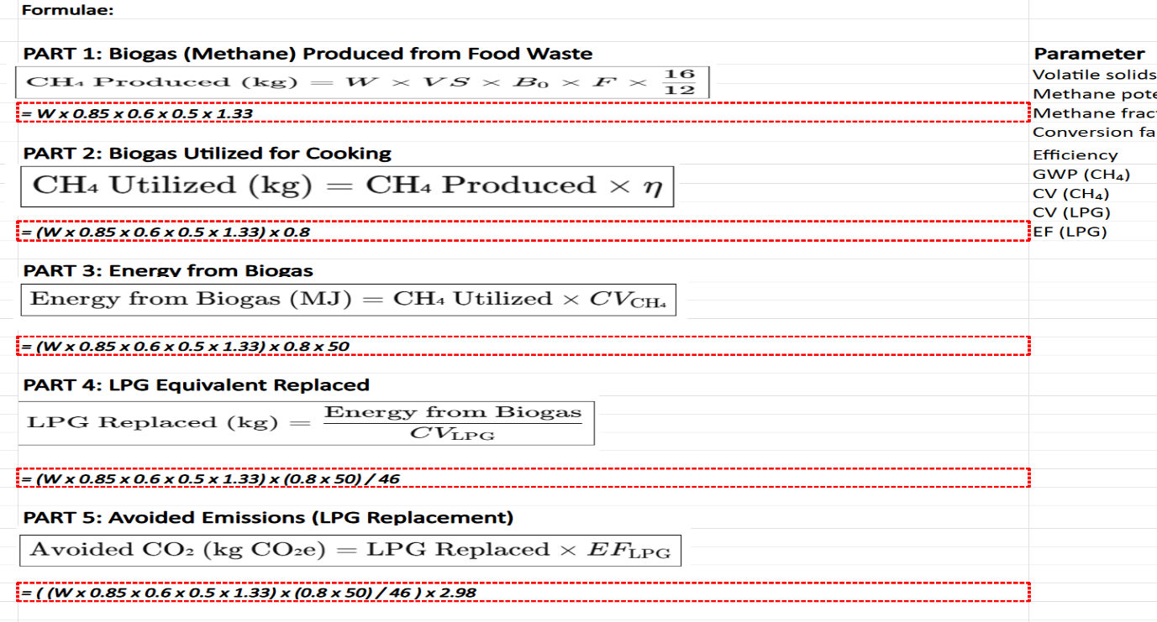
- Biogas/Food waste=

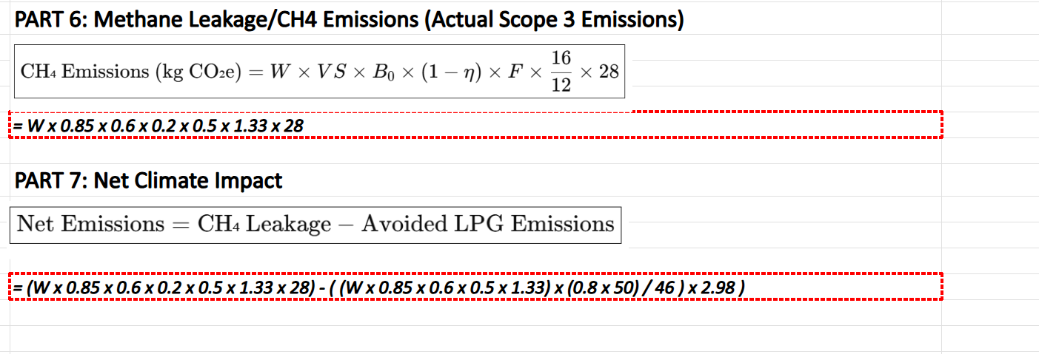

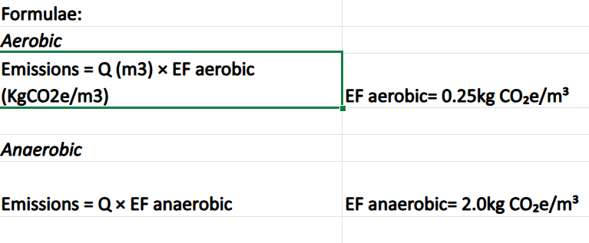
- STP: Emissions in (KgCO2e)

- Sludge Energy: Emissions (KgCO2e)= Q or Sludge Produced in Kg x EF sludge(KgCO2e/Kg)
Avoided Emissions (KgCO2e) = Energy produced from sludge (KWh) x EF of electricity (KgCO2e/KWh)
Energy Produced from Sludge = Q (Kg) x CV (KWh/m3) x Y biogas (m3/Kg)

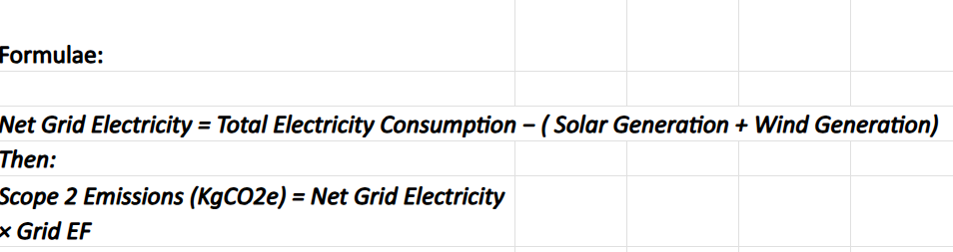
Scope 2 Purchased Electricity:

Scope 3
- Garden Waste: Emissions (KgCO2e) = Garden Waste (Kg) x EF (KgCO2e/Kg)
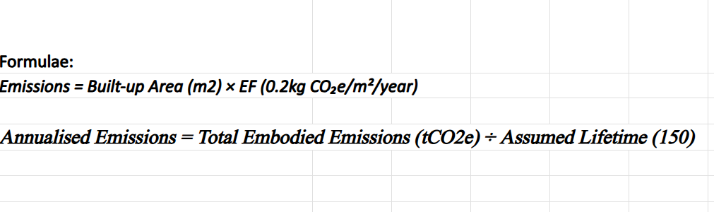
- Embodied Emissions:

- Commuters: Emissions in KgCO2e = No. of commuters × Distance (up and down) in Km × Working Days x EF (KgCO2e/Km)

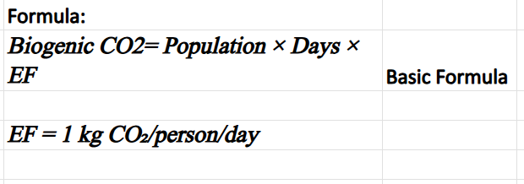
Biogenics:

